**ISLAM**

**Night of Power**

Laylat al-Qadr is the Night of Power, believed to be when the Quran was revealed to Prophet Muhammad.

About Laylat ul-Qadr

The Night of Power and its spiritual significance.

Laylat ul-Qadr, also known as the "Night of Power," is considered the holiest night of the year for Muslims. It is the night when the Quran was first revealed to the Prophet Muhammad (PBUH) by the Angel Jibreel (Gabriel). Laylat ul-Qadr falls during the last ten days of Ramadan, with the 27th night being the most widely observed. This night is believed to be better than a thousand months, and acts of worship and prayer on this night carry immense reward. Muslims spend the night in prayer, seeking forgiveness, mercy, and blessings from Allah. It is a time for reflection, spiritual renewal, and drawing closer to Allah. The significance of this night is mentioned in the Quran in Surah Al-Qadr, where its importance is emphasized.

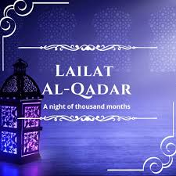

Laylat ul-Qadr Traditions

On Laylat ul-Qadr, Muslims engage in additional acts of worship, including reciting the Quran, making Dua (supplications), and performing extra prayers such as Tahajjud. Many Muslims spend the night in the mosque, in a state of worship, seeking Allah’s mercy and forgiveness. It is a night of increased devotion, where Muslims strive to purify their hearts and seek the pleasure of Allah. The 27th night is widely considered the most auspicious, but some scholars suggest it could fall on any of the odd-numbered nights during the last ten days of Ramadan. Charity is also an important part of this night, as giving to those in need is seen as a way of earning rewards during this blessed time.

Embrace the Blessings of Laylat ul-Qadr

Laylat ul-Qadr is a time for seeking Allah’s mercy, forgiveness, and blessings. It is a night of reflection, prayer, and spiritual renewal. May your prayers on this blessed night bring peace, joy, and divine blessings to you and your loved ones!